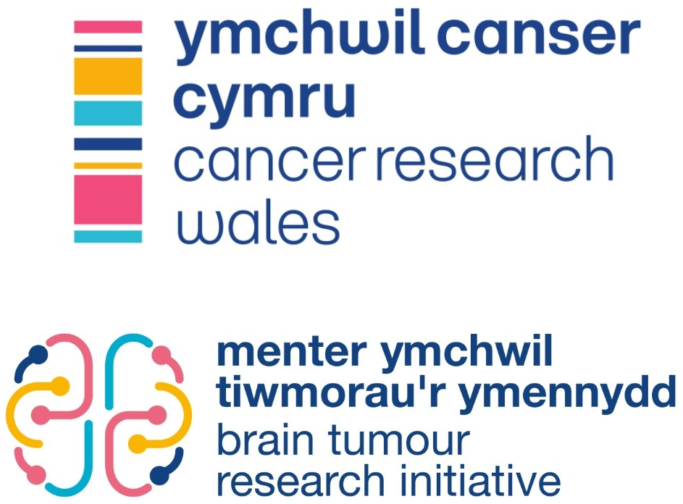

Expression of Interest
for Research Projects
Cancer Research Wales
22 Neptune Court
Vanguard Way
Cardiff
CF24 5PJ

Telephone: 02921 855050
E-mail: contact-us@cancerresearchwales.org.uk
Website: https://www.cancerresearch.wales

Registered Charity Number: 1167290

Cancer Research Wales
Cancer Research Wales was established in 1966 as the South Wales Cancer Research Council. This name was changed to Cancer Research Wales in 1990 in order to support requests for funding of research projects across Wales.
The charity’s objectives are to support cancer research and research facilities in partnership with the clinical services based at hospitals and other cancer centres in Wales and Universities based in Wales.
Through these avenues and by means of several grant schemes, Cancer Research Wales seeks to lessen the burden of cancer on the people of Wales, through research that is innovative, timely, sustainable and relevant to the challenges as they present in Wales and further afield.
Cancer Research Wales is very keen to support young research students and clinicians wishing to follow a career in cancer research by making grants available for them to pursue a higher degree, normally a PhD.

Expression of Interest

This Expression of Interest form will be used to assess the merits of the proposed research grant and its fit with the strategic priorities of the Cancer Research Wales Brain Tumour Research Initiative (BATRI).
At the expression of interest stage all applications will be assessed by the Scientific Committee for their suitability for full grant submission and will be evaluated using criteria set out in the Cancer Research Wales Research Strategy and Submission Guidelines. Copies of these can be found on the CRW website or by contacting the Head of Research.
It must be noted that Cancer Research Wales does not currently support grant applications that involve the use of animals.
We strongly advise all applicants to carefully review these two documents before submitting an application. Any applications that do not align with the research strategy or fail to comply with submission guidelines will not be considered.

Application Requirements

- Applications to Cancer Research Wales for research funding must adhere to the format set out in Sections 1 and 2.

- Applications should be submitted as an email attachment and sent to grants@cancerresearchwales.org.uk
- All applications must be returned by Monday 29th June 2026. All sections must be completed and late submissions will not be accepted.

Notification of Expression of Interest decisions will be made no later than 17th July 2026.
Successful applicants will be invited to submit a full research proposal by 28th September 2026.
Final grant awards will be made following a Board of Trustees Meeting in January 2027.

While every effort will be made to adhere to this schedule, Cancer Research Wales reserves the right to be flexible with regard to exact dates.

Brain Tumour Research Initiative

The Cancer Research Wales Brain Tumour Research Initiative (BATRI) has been set up to build a critical mass of research into brain and other central nervous system (CNS) tumours in Wales.
Unlike many other cancer types, brain tumours have shown little improvement in outcomes in recent decades, yet research has typically been underfunded. There is a real and unmet need for more research so that significant progress can be made in treating and caring for brain and CNS tumour patients.
The BATRI will fund brain tumour research across 5 broad themes, which aim to capture the breadth of research opportunities in this field. The below graphic displays the themes, as well examples of possible areas of research within them (N.B. these are not exhaustive).
Cancer Research Wales will consider proposals that do not fall under these themes if they are pertinent to brain tumour research. If you are unsure whether your proposal is appropriate, please contact Head of Research, Dr Lee Campbell (lee.campbell@cancerresearchwales.org.uk).
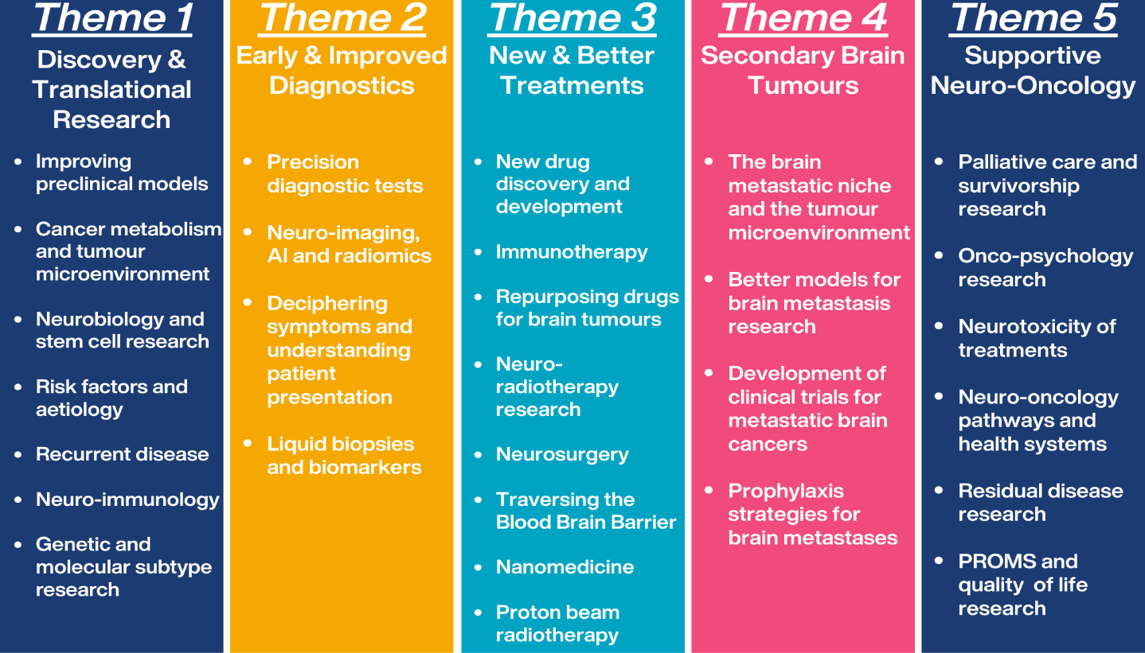

Basic Details

Project Title | Click or tap here to enter text.
Main Applicant

Full name and title | Click or tap here to enter text.
Department | Click or tap here to enter text.
Host institution | Click or tap here to enter text.

Co-Applicant(s)

Full name and title | Click or tap here to enter text.
Host institution | Click or tap here to enter text.

Full name and title | Click or tap here to enter text.
Host institution | Click or tap here to enter text.

Approximate Costs

Total Stipend/Salary | £ Click or tap here to enter text.
Tuition Fees | £ Click or tap here to enter text.
Running Expenses | £ Click or tap here to enter text.
Total Requested | £ Click or tap here to enter text.

For which type of grant are you applying?
PhD Studentship  (£110,000) | ☐ | Clinical PhD Studentship  (£240,000) | ☐
Project Grant Level 1  (£200,000) | ☐ | Project Grant Level 2  (£300,000) | ☐
Innovation Grant  (£40,000) | ☐
Figures specify maximum funding available for each grant type.

Discovery & Translational Research | ☐ | Early & Improved  Diagnostics | ☐
New & Better Treatments | ☐ | Secondary Brain Tumours | ☐
Supportive Neuro-Oncology | ☐
Which theme(s) best fits your proposed grant?

If successful, will your application be joint funded by another source?
Yes | ☐ | No | ☐
If YES, please provide details:

Has your proposed grant been previously submitted to Cancer Research Wales or another funding source?
Yes | ☐ | No | ☐
If YES, please provide details:

Proposal Details

Grant Proposal Outline
Please provide an overview of your proposed grant, including objectives and expected outcomes (max 600 words).

Fit with Brain Tumour Research Initiative
Please provide a description of how your proposed grant fits with the aims and themes of the Cancer Research Wales BATRI (max 250 words).

